**CAPSLink Group Sign On Application**

|  |  |  |
| --- | --- | --- |
| **First Name:** | Click or tap here to enter text. | |
| **Last Name:** | Click or tap here to enter text. | |
| **Email Address:** | Click or tap here to enter text. | |
| **CAPS Pharmacy Location:** | | Choose an item. |

**Instructions:** In the fields below please provide the requested account information. The first account in the list should be your “Default” account. This is the account that you will be logging into CAPSLink with. If you do not have a CAPSLink user account, please contact your CAPS pharmacy (for 503A) or Customer Service (for 503B). All other accounts will be accessible to you without an additional login and should be listed in the section “Other Customer Accounts”. You will be notified by email when your setup is complete.

**\*\*IMPORTANT\*\*** - When filling out the form make certain the Full Customer Account Name is exactly as it appears in the upper left of the CAPSLink home screen when you are logged into the account (see image below).

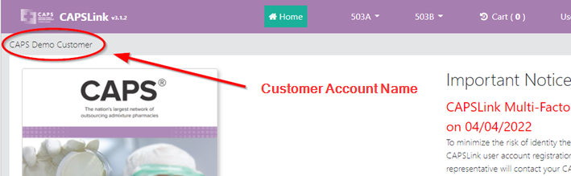

|  |  |
| --- | --- |
| **Default Customer Account** | |
| **CAPSLink Username** | **Full Customer Account Name** |
| Click or tap here to enter text. | Click or tap here to enter text. |
| **Other Customer Accounts You Need Access to (Full Name)** | |
| Click or tap here to enter text. | |
| Click or tap here to enter text. | |
| Click or tap here to enter text. | |
| Click or tap here to enter text. | |
| Click or tap here to enter text. | |
| Click or tap here to enter text. | |
| Click or tap here to enter text. | |
| Click or tap here to enter text. | |
| Click or tap here to enter text. | |
| Click or tap here to enter text. | |
| Click or tap here to enter text. | |
| Click or tap here to enter text. | |

**Please Email the completed form to** [CustomerService@CapsPharmacy.com](mailto:CustomerService@CapsPharmacy.com)